EXPERIMENT – 8

Privilege Escalation Using TryHackMe Platform

Aim
To understand and demonstrate Linux privilege escalation techniques by exploiting system misconfigurations and vulnerabilities using the TryHackMe platform.

Tools / Platform Required
- Web Browser (Chrome / Firefox)
- Internet Connection
- TryHackMe Account (Already Created)
- TryHackMe AttackBox (Built-in Linux Environment)
- Linux Privilege Escalation Tools (LinPEAS, sudo, find, etc.)

Theory (Brief)
Privilege Escalation is a technique used to gain higher-level permissions than originally assigned.
In Linux systems, attackers often exploit misconfigured permissions, vulnerable binaries, or weak sudo rules to escalate from a normal user to root.
TryHackMe provides a legal and controlled environment to practice privilege escalation techniques and understand real-world attack scenarios.

Steps to Perform the Experiment

Step 1: Login to TryHackMe
- Open browser and go to: https://tryhackme.com
- Login using your registered credentials.

Step 2: Open Privilege Escalation Room
- In the search bar, type Linux Privilege Escalation.
- Click on the appropriate room.
- Click Join Room.

Step 3: Start the AttackBox
- Click Start AttackBox.
- Wait for the Linux environment to load.
- Open the terminal inside AttackBox.

Step 4: Initial Enumeration
- Check current user:
- whoami
- Check system information:
- uname -a
- Check sudo permissions:
- sudo -l

Step 5: Identify Privilege Escalation Vectors
Common techniques explored:
- Sudo misconfigurations
- SUID binaries
- Weak file permissions
- Environment variable abuse
- Cron job misconfigurations
Example command:
find / -perm -4000 2>/dev/null

Step 6: Exploit Vulnerability
- Execute the vulnerable binary or misconfigured command.
- Escalate privileges to root user.
- Verify escalation:
- whoami

Step 7: Capture Flags / Complete Tasks
- Obtain root-level access.
- Capture the required flags.
- Mark all tasks as completed.

Output
- Successful privilege escalation from normal user to root.
- System commands executed with elevated privileges.

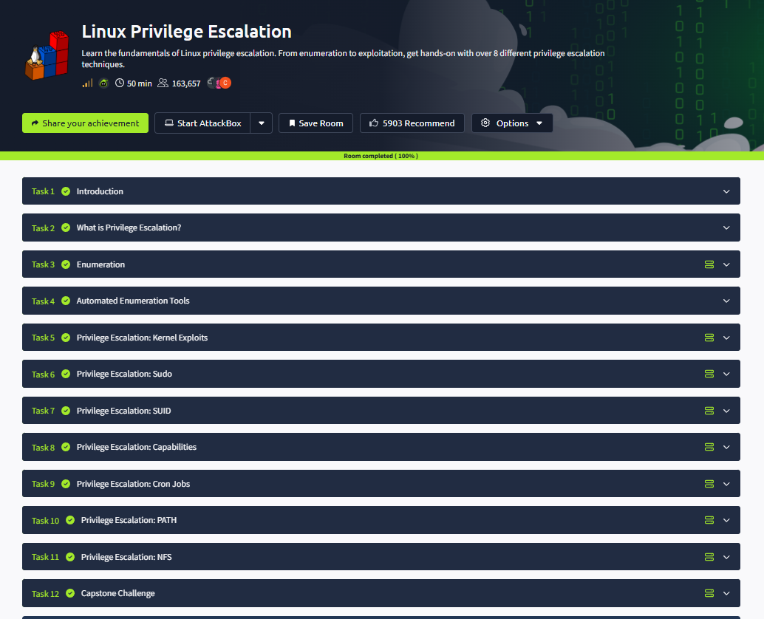

Result
Thus, privilege escalation was successfully performed using the TryHackMe platform.
The experiment provided hands-on understanding of Linux privilege escalation techniques and system security weaknesses.

⚠️ Important Note
This experiment is performed strictly for educational and ethical purposes using the TryHackMe learning platform.

